**Website & ERP System**

**For**

**IBILLS AUTO LANKA**

**(Vehicle service center)**

Higher National Diploma in Information Systems Management

24.1F

Final Project Proposal

**Name Index Number**

R.M.U.S. RATHNAYAKA KAHNDISM241F-008

M.G.K.E. WADUGODA KAHNDISM241F-012

R.M.A.G.N.T. RATHNAYAKA KAHNDISM241F-013

A.M.K.U.I.B. ABEYSINGHE KAHNDISM241F-014

**School of Computing and Engineering**

**National Institute of Business Management**

**Kandy**

**Table of Contents**

**Chapter 1: Introduction** 3

**1.1 Introduction for the Organization** 3

**1.2 Organization Structure** 4

**1.3 Current Operations in Organization** 5

**1.4 Users and Responsibilities Organization.** 6

**1.5 Illustrations of the current system** 8

**1.5.1 Use case diagram** 9

**1.5.2 Context diagram** 9

**1.5.3 Swimlane diagram** 10

**1.5.4 ER diagram** 11

**1.6 Problem Definitions** 12

**1.7 Project objectives** 13

**1.7.1 Main objectives** 13

**1.7.2 Sub objectives** 14

**1.8 Proposed Solution** 14

**1.8.1 Project scope** 15

**1.9 Expected outcomes** 15

**1.9.1 Website will feature** 16

**1.10 Chapter Summery** 17

**Chapter 2: Methodology** 18

**2.1 Introduction** 18

**2.2 Data Collection Methods** 18

**2.3 Software Process Model** 19

**2.4 Software development tools and techniques** 20

**2.5 Testing Strategies** 20

**2.6 Project Plan** 21

# **Chapter 1: Introduction**

## **1.1 Introduction for the Organization**

For this project, we decided to select ‘IBILLS Auto Lanka’, a service center that provides vehicle maintenance and repair services based on modern technology. This medium-sized service center, located at No. 99/1/1, Poojapitiya Medawala Road, Kandy City, was recently inaugurated by Mr. Isuru Hemachandra. This is the first service center in Sri Lanka to provide customers with the opportunity to scan and reprogram several vehicles other than their cars (three-wheelers, motorcycles) using Toyota Tech Stream. In addition, vehicle scanning and diagnostics, EFI engine tuning, diesel petrol engine repair, suspension system repair, engine oil and all types of oil changes, dry services, 4×4 vehicle repair, hybrid battery repair and service, ABS and SRS airbag repair. etc. are other services available to customers. Also, all types of spare parts required for the vehicle such as engine oil, suspension materials, coolant, brake rotors, steering, spark plugs, batteries, oil filters can be obtained from this location. Currently, the only way to service the vehicle and get services for the customer is to visit the service center. That is, a manual process is still in operation here. Contacting and asking for further information only through telephone facilities and social media can sometimes have a negative or positive impact on both parties. He said that customers currently must face various problems such as heavy traffic, delay in booking, evasion, difficulty in getting detailed information about the vehicle's faults, and not being able to know the opening and closing times of the service center. He further told us that a proper management system has not yet been developed to bring this medium-sized business to the customer when they come to the service center to get all the information about the services and to inform the customer about the service provided through the service center. As a solution to all the above problems, we took on the responsibility of creating the website he proposed so that the customer can communicate with the website easily from the comfort of their home, with a detailed explanation of the services required by the customer.

# **1.2 Organization Structure**

**Owner/manager**

**Workshop operators**

**Cashier**

**Technician**

**Helper**

# **1.3 Current Operations in Organization**

This project is a newly launched program and there is no operating system currently in place within the organization. That is, all the processes that occur within the automobile organization are currently built under a manual process. Since it has been built as a medium-scale business involving a very limited number of employees, there is only a social media background and telephone support to get information here, so the customer must bring his vehicle to this service center and inquire about its maintenance. Therefore, upon the request and need of the owners, it was decided to create a new system and a related website through the project with the aim of connecting new clients with the organization and making the service center a profitable, improved and efficient place. By adopting many features of a new improved technological system with the convenient online booking system for employees who receive services through the service center.

**Owner:** He is responsible for the stakeholders, employees, customers and the organization that deals with the service center. He manages, directs, and makes decisions about all vehicles that come to the service center. He also handles all activities such as calls and coordination from customers, planning financial transactions, and managing inventory. Here, all information is managed under a manual process.

**Technician:** Since technical support is not currently available to diagnose the problem with the vehicle, the maintenance and repair of vehicles that come to the service center are carried out based on the experience and expertise gained. For that reason, all the defects in the vehicle are documented and the customer is informed through it. Since there is no opportunity to see the vehicle given to the service center for maintenance under technical facilities or to inquire about the current maintenance work, it is necessary to visit the service center and check until the message is received through regular technicians.

**Helper:** Assists technicians in completing repair and maintenance tasks

**Cashier:** Managing customer transactions for the services provided and managing daily financial reports. summarizing earnings and reporting any discrepancies.

# **1.4 Users and Responsibilities Organization.**

Current

Currently the company has a very limited number of employees, consisting of the owner, a workshop operator, and a cashier.

**Owner/manager**

He is the owner of the company and has overall responsibility for the profitability and strategy of the service center operations. He also leads and manages the employees. In addition, the management of finance and accounting is also handled by the company owner. He is also responsible for managing budgeting, financial reporting and expense control. He also manages all types of vehicle parts and inventory. Managing spare part inventory sourcing and ensures availability for repairs. Responsible for stock control, storage and documentation.

**Workshop operators**

All vehicle problems are diagnosed, repaired and maintained.

**Helper**

Support technicians with basic tasks and learn under their guidance.

**Cashier**

Handles billing, payments and petty cash transactions

Proposed

The revamped process and the newly designed website will result in a different division of staff and responsibilities within the organization.

**Owner**

He is the highest authority responsible for setting the goals, vision, and objectives of the service center, as well as the overall strategy. He oversees all departments and approves major decisions.

**General manager**

Directly liaises with the institution's ownership and performs reporting and communication activities. All department managers are supervised and ensure that all activities are aligned with the institution's objectives.

**Department managers**

Several departments consisting of significant staff and officers are to be formed in this institution soon. Therefore, each manager will supervise their respective department and report to the general authority.

* **Workshop Manager:** Manages workshop operations, technicians, and quality control.
* **Finance and Accounts Manager:** Oversees budgeting, financial planning, payroll, and accounting tasks.
* **HR Manager:** Handles recruitment, training, employee relations, and compliance with labor laws.
* **Customer Relationship Manager (CRM):** Ensures high levels of customer satisfaction, manages feedback, and handles escalations.
* **Web and Social Media Manager:** Manages the company’s online presence, including website updates, social media platforms, and digital marketing campaigns.
* **Inventory Manager:** Manages spare parts procurement, stock levels, and inventory control.

**Supervisors**

Supervisors and specialists in this role must supervise, direct, and communicate with all processes performed by employees related to the department to which they belong. They must direct employees in accordance with the orders received from top management and report to department managers.

**Operational staff**

These roles report to the supervisors or directly to departmental managers.

* **Technicians:** Perform diagnostics, repairs, and maintenance services.
* **Support Staff:** Includes drivers for vehicle pickup/drop-off, cleaners for maintaining cleanliness, and helpers for assisting in routine tasks.

# **1.5 Illustrations of the current system**

Since no system has been prepared at current, the process that takes place in the proposed system is as follows

## **1.5.1 Use case diagram**

## **1.5.2 Context diagram**

## **1.5.3 UML Diagram Level 0**

## **1.5.4 Swimlane diagram**

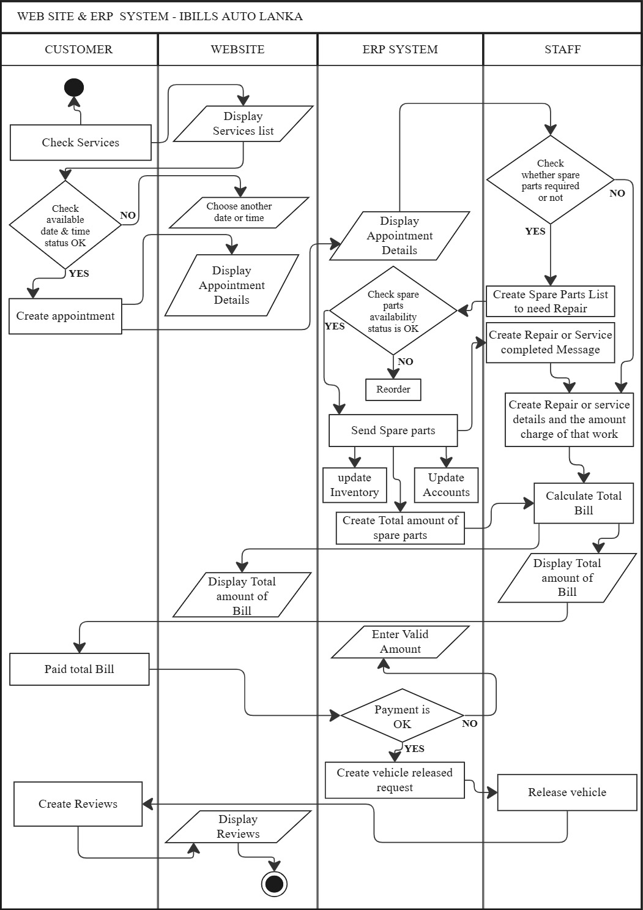

## **1.5.5 ER diagram**

# **1.6 Problem Definitions**

**Limited visibility**

The business owner said that one of his main challenges is not having a proper plan in place to educate and advertise his service center and the services he offers to customers. Without a properly maintained website presence potential customers will not be able to find the service center when searching online. This can lead to lost business opportunities as many people search for services online before traveling. Inefficient appointment scheduling

Due to the lack of a system in place to properly reserve a time slot for clients to visit the service center, the limited staff within the organization has been unable to properly manage the clients who come to receive services daily. This means that the organization has had to face problems such as not knowing the correct errors, missing appointments, facing excessive traffic, not properly managing the communication process between the two parties, inability to manage time, and some errors in financial transactions.

**Poor Customer Communication**

Without a digital system, communicating with customers about service updates, promotions, or reminders can be challenging. This can lead to misunderstandings and dissatisfaction.

**Inventory Management Issues**

A lack of a system to track parts and supplies can result in overstocking or running out of essential items, affecting service delivery and customer satisfaction.

**Inadequate Reporting and Analytics**

Without a digital system, tracking performance metrics, customer feedback, and service history becomes difficult. This can hinder decision-making and improvement efforts.

# **1.7 Project objectives**

## **1.7.1 Main objectives**

**Develop a user-friendly website**

The primary objective of this is to create a website that will attract new customers and facilitate the process for customers who have already received our services, by including a variety of features such as services provided to employees through the service center, price displays, special discounts, and facilities.

**Providing online booking facility to customers**

We hope to update the features so that the customer can easily book the desired time and date through the website according to the availability of dates and times. This is done in a systematic manner by setting up an accurate schedule. Our goal is to create a process that is easy for both parties by minimizing congestion, time, effort and errors.

## **1.7.2 Sub objectives**

**Customer Relationship Management**

By creating an account and registering new customers on the website they can gain insight into all the processes that are taking place in our service center. That is after booking they could gain insight into the progress of the maintenance work carried out on the vehicle provided to us with the start date, during the maintenance and the final period under a tracking process. Another objective of creating our website can be pointed out to notify the registered account via SMS as soon as the maintenance work is completed.

**Automate Inventory Management**

Use inventory management software to track parts and supplies in real-time. This will help maintain optimal stock levels and ensure that necessary items are always available.

**Generate Reports and Analytics**

Set up systems to collect data on customer behavior, service performance, and financial metrics. This will provide valuable insights for making informed business decisions.

# **1.8 Proposed Solution**

The main objective of this service center, which is currently being developed manually without any updated system or process, is to create an efficient and effective website using modern technological concepts as per their needs and requests. That is, we create a website as a solution to streamline the daily process, provide services to the clients by minimizing problems, connect new clients to their service centers, and encourage them to be a popular and productive place among many people. Not only customers who connect to the website, but also internal employees need to build a system that is connected to the website and operates so that they can gain an understanding of the processes taking place within the organization. This will make it easier for the organization owner to gain a comprehensive understanding of the booking, inventory, finance & accounting departments.

## **1.8.1 Project scope**

The project scope involves creating a user-friendly website for IBILLS Auto Lanka to improve customer experience and streamline operations. The website will include features like online booking, service tracking, and notifications. It will also automate inventory management, billing, and reporting, making processes more efficient. The project aims to enhance the service center's online presence, improve customer communication, and support better management of staff roles and responsibilities, ultimately increasing profitability and customer satisfaction.

# **1.9 Expected outcomes**

Our main hope is to create an attractive website that will enable the owner to obtain and inquire about all the services provided using modern technology and to book a convenient time before visiting the service center using software tools and technics. Not only the customers but also the staff at the service center can get an understanding of the daily process, especially for the corporate owner, an assessment of appointment, supply, budget, and warehouse management through the system connected to the website.

## **1.9.1 Website will feature**

* **Appointment**

A reservation system has been provided for service providers who connect with the website to obtain services according to their needs and convenient date and time.

* **Chatbot**

It is planned to set up an automated robot on the website to provide answers to any information, problem or further inquiries that any subscriber visiting the website may require.

* **Tracking processes**

Once they arrive at the service center and hand over their vehicle, the process is tracked from the start of the maintenance, the moment the inspection is performed, and the end date. Registered service providers will then not have to constantly check the progress of the maintenance.

* **Automated SMS System**

After all the work on the service provider's vehicle is completed, a notification is sent via SMS to the registered account of the vehicle owner, who has completed the maintenance work, in conjunction with a tracking process.

* **Customer reviews**

We hope to make the website more open to new and existing customers, along with the photos they post, so that they can see the quality of the progress being made at the service center.

# **1.10 Chapter Summery**

The chapter focuses on the modernization of IBILLS Auto Lanka, a medium-sized vehicle service center in Kandy City, by addressing its current manual operations and operational inefficiencies. The service center struggles with limited visibility, inefficient appointment scheduling, poor customer communication, and inadequate inventory management. To resolve these issues, a user-friendly website is proposed, offering features such as online booking, service tracking, automated SMS notifications, and real-time inventory management. Additional elements like chatbot support and customer review integration will enhance customer satisfaction. The project aims to streamline daily operations, improve customer experience, and provide better management insights for the owner, ultimately increasing profitability and efficiency.

# **Chapter 2: Methodology**

## **2.1 Introduction**

Information related to the activities required for the website being created for Auto Lanka and the system built in connection with it, from the initial step to the final stage, should be collected. After discussing the ideas, we proposed with the owner of the institution, data collection related to all the methods required to make these new products successful began.

## **2.2 Data Collection Methods**

**Online research**

The main hope of the owner of the company was to adapt to the relevant environment to face the competition that is already present in many areas of the city. His plan was to turn this company, which is currently a medium-sized company with a limited number of employees, into a more productive and advanced workplace in the future. First, the main step can be shown to be to ensure that the required supply is received by the customer through the collection of information related to the employee's needs. As a solution to this, it was decided to conduct online research to obtain the data of the customer.

It was decided to prepare a relevant questionnaire and release a Google form to collect information for the main cities of Kandy, Matale, Kurunegala and the areas surrounding those cities and release it on social media. By gaining an accurate understanding, it will be possible to improve the website and easily provide the services required by the customer

**Interviews and Focus group**

Interviews with the owner and staff within the organization can help them understand the steps needed to facilitate services. (Identification of needs and services to be provided occurs here).

By using focus groups, we can gather the requests and needs of the staff as well as important points for the convenience of the client, and then discuss with our team members what steps to take to formulate relevant ideas.

**SWOT analysis**

Here, strengths, weaknesses, opportunities and threats that affect the service center, employees and customers can be identified separately.

## **2.3 Software Process Model**

**Requirement Analysis**

**Design**

**Implementation**

**Testing**

**Development**

**Maintains**

## **2.4 Software development tools and techniques**

* Front end development-Html, CSS, Bootstrap, React JS
* Figma - UI prototype
* Backend- PHP, JavaScript
* Database- Oracle, MySQL
* Version control- GitHub
* Project management tools- Trello
* Statistic tool- SPSS, R
* Business analysis tool- User story

## **2.5 Testing Strategies**

**1. Usability Testing**: Assess how easy it is for customers to navigate the website. This involves observing users as they interact with the site to identify any difficulties they encounter.

**2. Performance Testing:** Evaluate the website's loading speed and responsiveness. This ensures that customers can access information quickly without delays, which is critical for user satisfaction.

**3. Functionality Testing:** Verify that all features of the website work as intended. This includes checking appointment scheduling, service descriptions, and payment processing to ensure they function correctly.

**4. Cross-Browser Testing:** Test the website on different web browsers (like Chrome, Firefox, Safari) and devices (mobile, tablet, desktop) to ensure a consistent experience for all users.

**5. Security Testing:** Conduct assessments to identify vulnerabilities on the website, especially in areas that handle customer data, such as payment processing and personal information forms.

## **2.6 Project Plan**

|  |  |  |  |  |  |  |  |  |  |  |  |  |  |  |  |  |
| --- | --- | --- | --- | --- | --- | --- | --- | --- | --- | --- | --- | --- | --- | --- | --- | --- |
|  | **2024** | | | | **2025** | | | | | | | | | | | |
| **GANTT CHART**  **December** | | | | **January** | | | | **February** | | | | **March** | | | |
| **Task** | **1** | **2** | **3** | **4** | **1** | **2** | **3** | **4** | **1** | **2** | **3** | **4** | **1** | **2** | **3** | **4** |
| **Project Topic & Company selection** |  |  |  |  |  |  |  |  |  |  |  |  |  |  |  |  |
| **Project start date (group registration)** |  |  |  |  |  |  |  |  |  |  |  |  |  |  |  |  |
| **Project proposal submission** |  |  |  |  |  |  |  |  |  |  |  |  |  |  |  |  |
| **Project proposal VIVA** |  |  |  |  |  |  |  |  |  |  |  |  |  |  |  |  |
| **Data collection (online research)** |  |  |  |  |  |  |  |  |  |  |  |  |  |  |  |  |
| **Data collection (Interviews & focus group)** |  |  |  |  |  |  |  |  |  |  |  |  |  |  |  |  |
| **Analysis of collected data** |  |  |  |  |  |  |  |  |  |  |  |  |  |  |  |  |
| **Data collection (SWOT analysis)** |  |  |  |  |  |  |  |  |  |  |  |  |  |  |  |  |
| **Business analysis** |  |  |  |  |  |  |  |  |  |  |  |  |  |  |  |  |
| **System design** |  |  |  |  |  |  |  |  |  |  |  |  |  |  |  |  |
| **Development (HTML, CSS, Oracle, JS, BOOTSRAP, PHP, MY SQL)** |  |  |  |  |  |  |  |  |  |  |  |  |  |  |  |  |
| **Testing** |  |  |  |  |  |  |  |  |  |  |  |  |  |  |  |  |
| **Project documentation** |  |  |  |  |  |  |  |  |  |  |  |  |  |  |  |  |
| **Final project Implementation** |  |  |  |  |  |  |  |  |  |  |  |  |  |  |  |  |
| **Final project Submission & Viva** |  |  |  |  |  |  |  |  |  |  |  |  |  |  |  |  |